ECE 890 - Spring 2015 **Test 2 In-Class Component** Name _____________________

(80 points total)

1. (5pts) The control has been proposed for the system model shown below. The system parameters a,b,c > 0. The controller will then be applied to the actual system. Describe three potential weaknesses in the proposed control.



Potential weakness 1: Exact model knowledge control, may not be able to exactly measure the parameters of the physical system

Potential weakness 2: Canceled the term which naturally acts to stabilize the system, i.e. control signal may be unnecessarily large.

Potential weakness 3: The term  causes a singularity at 

Potential weakness 4: May have error in the measurement of 

Potential weakness 5: May have un-modeled dynamics in the original system that aren’t accounted in the control design

Potential weakness 6: Need to state that k>0

1. (5pts) For the system shown, describe in a few sentences how the backstepping approach works. What is your control objective? How does *u* act? You are not actually designing the control.

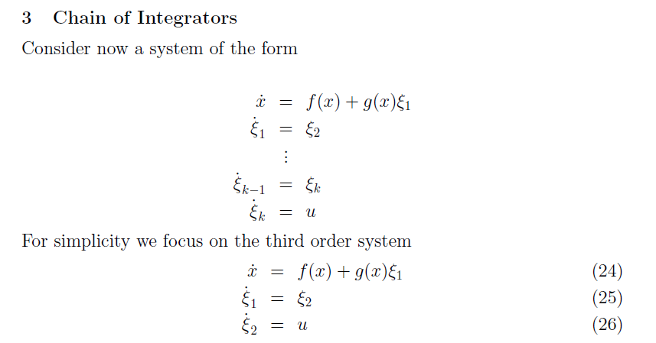

Treat the system as though Xi1 is the direct input to the top equation and design a (feedback) control and call it Xi1desired. Design Xi2 as though it is the direct input to the middle equation so that Xi1 will track Xi1desired, and in effect Xi1desired is applied to control the state x. Finally, design the actual system input u so that Xi2 follows Xi2desired, and in effect Xi2desired is applied to control the state Xi1. Through this chain of embedded controls the input u controls the state x.

1. (10pts) are given. Show that the system is exponentially stable at the origin.







